AP Literature: A Doll’s House Creative Project
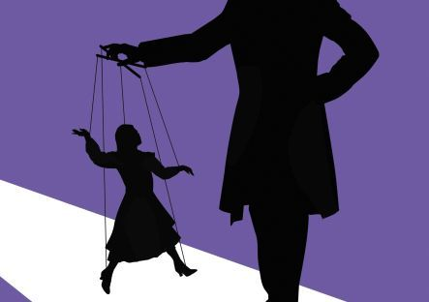

Directions: You will be working in groups of four. Each group will be given a flip camera and four days to work in class. Projects are due September 22nd.
A Sequel
While The Doll House ends with a slamming door, Nora seems to leave a possible opening for Torvald to learn his lesson. Because Ibsen’s ending has spurred controversy among audiences and critics alike, write an additional ending scene, making clear whether Nora eventually returns to Torvald or embarks on a life of her own forever. It should be obvious that you have clearly read and understood all aspects of the original play. You will then film a commercial for your sequel in which you give a sneak peek into what audiences can expect from this next chapter in the story. You will need to mimic Ibsen’s language, illustrating your comprehension of his style of writing.
Rubric:
Typed script 40 points
Adherence to Ibsen’s style of writing/speaking 10 points
Complexity character and theme that is true to the story 30 points
Costumes/props 10 points
Effort/preparation/video quality 10 points

*On September 22nd, we will have a viewing party! You are welcome to bring popcorn and drinks. We will watch all of the commercials and then AP Oscars will be given out.*

