AP Literature Terms Project
Board Game Project
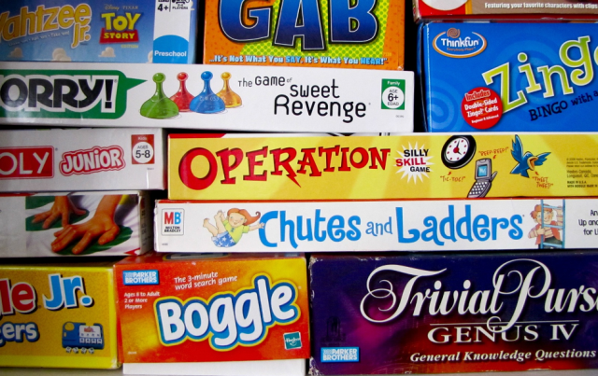
Directions:
- You are to create a board game that features all 100 AP literature terms and their definitions.
- Your game must include a board. The spaces and places on the board should reflect a common theme. You may pattern your game after an existing game (Sorry!, Monopoly, Trivial Pursuit, etc.) or create a whole new game.
- Your game MUST require the players to give either a definition in response to a term or a term in response to a definition. The goal of these games is to be a comprehensive review of the AP literature terminology. An answer key MUST be provided somehow.
- Your directions must be clear and precise. It should explain how to set up the game, how to play it, and how to win. Suggestion: Give the directions to a friend or parent not in your group and see if they can set up and play it without your assistance. If not, adjust the directions until there is no help needed from you.
- Your board should be visually appealing. It should be colorful and neat.
Getting Started:
- Decide what type of game they you create and what the ultimate goal will be. (Examples: Becoming King of AP Literature Mountain, earning a 5 on the exam, etc.)
- Decide how you will present the terms and definitions.
- Design the game board. What will be on the board? How will you create the spaces? Plan the board out on paper first, and then create the board itself. Even if you are only using cards, you will still need a creative game board.
- Design the playing pieces and decide how they will move. Will you need dice? A spinner? Extra cards?
- Plan out and then type up your rules/directions sheet.
Group Member(s):
Rubric for Game Board Project
- Visual Appeal 1 2 3 4 5
- Colorful
- Interesting
- Writing easy to read
- Creative title
- Instructions 2 4 6 8 10
- Neatly printed
- Clear and precise
- Show the ultimate goal
- No additional explanations needed on game-playing day
- Overall focus 10 20 30 40 50
- Includes all 100 terms
- Includes all 100 term definitions
- Information was accurate
- Accurate answer key for all questions provided
- Pieces 2 4 6 8 10
- Handmade board
- All pieces required present
- Dice/spinner/other to move pieces (if needed)
- Cards (if needed)
- Peer Evaluation 5 10 15 20 25
- How playable was the game
- How fun or enjoyable was the game (keep in mind it’s a school project…)
- How effective was it at helping you to review

Teacher Total /75
Peer Evaluation /25
Project Total /100
Comments:

