Dead Poets Society 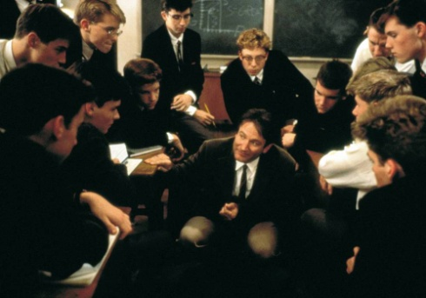

(Beginning of movie to the end of Mr. Keating's "O me! O life!" speech – approx. 32 min.)
1. Where and when is this story set?
2. What are the four pillars of Welton Academy? What do the students say they are?
T— T—
H— H—
E— E—
D— D—
3. Notice the short scene with the flock of birds. What might this scene symbolize?
4. What does the Latin phrase carpe diem mean?
5. What is the point of Mr. Keating's first class with the boys?
6. According to Mr. Keating, why read poetry?
7. Why does he have them rip pages out of their books?

(First dinner scene to students standing on Mr. Keating's desk—approx. 20 minutes)
8. What was the Dead Poets Society? What did they do? Where do you think the name comes from?
9. What is the symbolism in the scene where the boys go to the cave? Think about the cave itself, the setting in the woods, the flashlights, etc.)
10. How does Mr. Keating get the boys to look at life differently? What specific techniques or methods does he use?
11. What does T.S. Eliot mean by the following quote?

"No poet, no artist of any art, has complete meaning alone. His significance, his appreciation, is the appreciation of his relation to the dead poets and artists. You cannot value him alone; you must set him, for contrast and comparison, among the dead."
-- T. S. Eliot, from "Tradition and the Individual Talent"

12. Summarize, in your own words, why Henry David Thoreau went to the woods:

"I went to the woods because I wished to live deliberately, to front only the essential facts of life, and see if I could learn what it had to teach, and not, when I came to die, discover that I had not lived. I did not wish to live what is not life, living is so dear; nor did I wish to practice resignation, unless it was quite necessary. I wanted to live deep and suck out all the marrow of life, to live so sturdily and Spartan-like as to put to rout all that was not life, to cut a broad swath and shave close, to drive life into a corner, and reduce it to its lowest terms, and if it proved to be mean, why then to get the whole genuine meanness of it, and publish its meanness to the world; or if it were sublime, to know it by experience, and be able to give a true account of it in my next excursion. For most men, it appears to me, are in a strange uncertainty about it, whether it is of the devil or of God. . . ."
--Henry David Thoreau, from Walden

(From Neil's desire to act to Charlie's punishment—approx. 35 minutes)
13. What is Mr. Keating's philosophy of sports?
14. What is it that makes Todd come out of his shell? What does Mr. Keating do to help him come out of his shell?
15. Notice the music involved in the film (Handel, Beethoven). Why do you think this type of music was chosen?
16. Discuss the poems used in the film so far (Shakespeare’s sonnets, Robert Frost, Walt Whitman, Thoreau, etc.). What significance do the poems have on the storyline? Why do you think certain poems were chosen over others?
17. Professor Keating uses the following quote from Walt Whitman to inspire his students earlier in the film:
O Me! O life! . . . of the questions of these recurring;
Of the endless trains of the faithless—of cities fill’d with the foolish;
Of myself forever reproaching myself, (for who more foolish than I, and who more faithless?)
Of eyes that vainly crave the light—of the objects mean—of the struggle ever renew’d;
Of the poor results of all—of the plodding and sordid crowds I see around me;
Of the empty and useless years of the rest—with the rest me intertwined;
The question, O me! so sad, recurring—What good amid these, O me, O life?
Answer.
That you are here—that life exists, and identity;
That the powerful play goes on, and you will contribute a verse.

Why do you think Professor Keating tells his students to “contribute a verse?” What does he mean? What do you think will be your ‘verse’ to the world?

(Mr. Keating's meeting with Nolan to Knox's talk with Chris—approx. 19 minutes)
18. Do you think Charlie is too daring? Why or why not?
19. Do you think Mr. Keating is a bad influence? Why or why not?
20. What does Mr. Keating do well as a leader? What are his downfalls as a leader?
21. Keating provokes defiance into his students without providing the social discourse (or, in other words, something to try and change) for true change. What is the effect of this when the students act on their defiance?

(The rest of the movie –approx. 30 minutes)
22. Who is most to blame for Neil’s death? Mr. Keating? Neil’s father? Neil himself?
23. Do you think Neil would have committed suicide if Mr. Keating had never come into his life? Why or why not?
24. Who, do you think, was the bravest of all the Dead Poets boys? Why?
25. In the initial screenplay, Todd specifically does not sign the paper at the end. In the movie, we are not told one way or the other. Did Todd sign it or not? What do you think?
26. What happens next? What does the future hold for Keating and the boys?
27. Comment on each of the themes below—which theme were you most able to relate to? Which did you think was the most powerful?
▪ Feelings of alienation
▪ Dealing with increased feelings of independence and rebellion
▪ Academic pressure
▪ Symbolism and imagery
▪ Influence of role models
28. How has this movie helped you to think differently about poetry, teaching, school, alienation, etc. Pick one thing and focus on it.
29. Which piece of poetry used in the film did you like best and why? Why did it stand out to you?

