Macbeth Act 4, scene 1: The Witches’ Second Predictions
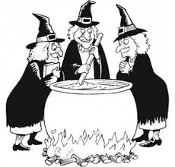
Directions: Using your textbook pgs. 382-383, describe the witches’ new predictions for Macbeth. Be very specific!
Apparition | What does it look like? (stage directions) | What does it symbolize? (use side notes) | What does it tell Macbeth? | How does Macbeth react?
First Apparition

Second Apparition

Third Apparition

Fourth Apparition

