Crime and Punishment:
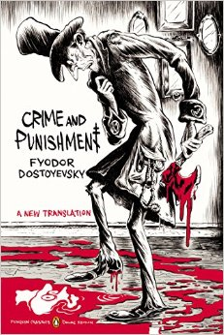

Quote Journals:
For each major section of the novel you will identify quotes that speak to you. Find a moment of brilliance, an interesting insight, a funny joke, a terrifying thought, or simply something that you found thought-provoking. Provide the quote and then a 4-5 sentence analysis that either relates the quote to the work as a whole, or provides insight into the mind of the character. The format of your quote journal can be in a manner of your choosing. Be creative!
Reading Schedule:
Section | Reading Deadline | Quote Journal
Part 1 | 1/12/16 | 4 quotes due
Part 2 | 1/22/16 | 4 quotes due
Part 3 | 1/29/16 | 3 quotes due
Test Parts 1-3 2/2/16
Fishbowl discussion using quote journals 2/3/16
Section | Reading Deadline | Quote Journal
Part 4 | 2/12/16 | 3 quotes due
Part 5 | 2/19/16 | 2 quotes due
Part 6 + Epilogue | 2/29/16 | 4 quotes due
Test Parts 4-6 3/1/16
Fishbowl discussion using quote journals 3/2/16

